# Exercise-1

Write the HTML code which use of:

* The italics tag
* The Center tag
* The paragraph tag
* The Break tag
* The Font tag and its attributes

**For the following text content**

***Beware of password hackers and crackers!***

The threat of hackers and crackers is for real, and is alike for everything for everyone. If the security breach at the Babha Atomic Research Center last year by the hacker group milworm didn’t convince you of their capabilities, then consider this: James Davis aka jdavis_a, a resident of [www.geocities.com/SiliconValley/Bit/2483](http://www.geocities.com/SiliconValley/Bit/2483) homestead community on the Internet, might just be reading your e-mail in your mailbox right now, or using your account for some benign Internet surfing, or exchanging it with someone else on the Net for more such accounts!

Surprised? Or scared?

**Formula:**

(a-b)2 = a2 - 2ab + b2

C6H12O6 + 6O2

Whatever it is, jdevis_4 claims in his home page Free VSNL passwords that he has got exactly 108 working passwords (and growing daily), *36 satyam, 31 MNTL, 11 WimiNet and 23 online passwords.*

|  |  |
| --- | --- |
| Top of Form  Line wrap  Bottom of Form | |
|  | <html><!DOCTYPE html> |
|  | <html> |
|  | <head> |
|  | <meta charset="utf-8"> |
|  | <title>exercise1</title> |
|  | <style> |
|  | h1{text-align: center;} |
|  | h3{color: red;} |
|  | </style> |
|  | </head> |
|  | <h1><i>Beware of password hackers and crackers!</i></h1> |
|  | <hrcolor="cyan"> |
|  | <body> |
|  | <p>The threat of hackers and crackers is for real, and is alike for everything for everyone. If |
|  | the security breach at the Babha Atomic Research Center last year by the hacker group |
|  | milworm didn’t convince you of their capabilities, then consider this: James Davis aka |
|  | jdavis_a, a resident of <a href="<https://www.geocities.com/SiliconValley/Bit/2483>">www.geocities.com/SiliconValley/Bit/2483 </a> homestead community |
|  | on the Internet, might just be reading your e-mail in your mailbox right now, or using |
|  | your account for some benign Internet surfing, or exchanging it with someone else on the<br> |
|  | Net for more such accounts!<br>Surprised? Or scared?<br> |
|  | <h3>Formula:</h3> |
|  | (a-b)<sup>2</sup> = a <sup>2</sup>- 2ab + b <sup>2</sup><br><br> |
|  | C <sub>6</sub> H <sub>12</sub> O <sub>6</sub> + 6O <sub>2</sub><br><br> |
|  | Whatever it is, jdevis_4 claims in his home page Free VSNL passwords that he has got |
|  | exactly 108 working passwords (and growing daily), 36 <i>satyam</i>, 31 MNTL, 11 <i>WimiNet</i> |
|  | and 23 <i>online passwords</i>. |
|  | </p> |
|  |  |
|  | </body> |
|  | </html> |

# Exercise-2

Looking at the screen given below write the HTML code making use of following tags

Unordered Lists

Ordered Lists

Definition Lists

Heading tag

**Text Content**

# Heading 1: Example on Unordered List

* Sportstar
* Business Week
* Time

# Heading 2: Example on Ordered List

* 1. Sportstar
  2. Business Week
  3. Time

**Heading 3: Example on Definition List**

Sports Magazine

Sportstar

Business Magazine

Business Week

<html><!DOCTYPE html>

|  |
| --- |
|  |
|  | <html> |
|  | <head> |
|  | <meta charset="utf-8"> |
|  | <title>exercise2</title> |
|  | </head> |
|  | <body> |
|  | <h1>Example of Unordered List</h1> |
|  | <ul> |
|  | <li>Sportstar</li> |
|  | <li>Business Week</li> |
|  | <li>Time</li> |
|  | </ul> |
|  | <h2>Example of Ordered List</h2> |
|  | <oltype="i" start="4"> |
|  | <li>Sportstar</li> |
|  | <li>Business Week</li> |
|  | <li>Time</li> |
|  | </ol> |
|  | <h3>Example on Definition List</h3> |
|  | <dl> |
|  | <dt>Sports Magazine</dt> |
|  | <dd>Sportstar</dd> |
|  | <dt>Business Magazine</dt> |
|  | <dd>Business Week</dd> |
|  | </dl> |
|  | </ol> |
|  | </body> |
|  | </html> |

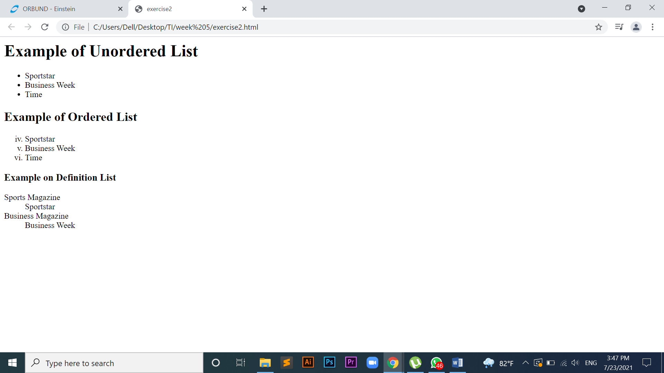

# Exercise-3

Design a **two**web page according to the following specifications.

## **Page 1 detail:**

Use “landscape.jpg” image as page background and display the content on top of it. Text content should visible, background image should not affect the text content.

## **Page 2 detail:**

Use “BLACK color” as background color and display text content on top of it using “WHITE color”

**Text Content**

# What is Web Design?

Web design refers to the design of websites that are displayed on the internet. It usually refers to the user experience aspects of website development rather than software development. Web design used to be focused on designing websites for desktop browsers; however, since the mid-2010s, design for mobile and tablet browsers has become ever-increasingly important.

|  |  |  |  |
| --- | --- | --- | --- |
|  | | |  |
| Top of Form    Bottom of Form | |
|  | <html><!DOCTYPE html> |
|  | <html> |
|  | <head> |
|  | <meta charset="utf-8"> |
|  | <title>ex3</title> |
|  | </head> |
|  | <body bgcolor="black" text="white"> |
|  | <h1 align="center"><i>What is Web Design?</i></h1> |
|  | <p>Web design refers to the design of websites that are displayed on the internet. It usually |
|  | refers to the user experience aspects of website development rather than software |
|  | development. Web design used to be focused on designing websites for desktop |
|  | browsers; however, since the mid-2010s, design for mobile and tablet browsers has |
|  | become ever-increasingly important. |
|  | </p> |
|  |  |
|  | </body> |
|  | </html> |

|  |  |
| --- | --- |
| Top of Form    Bottom of Form | |
|  | <html><!DOCTYPE html> |
|  | <html> |
|  | <head> |
|  | <meta charset="utf-8"> |
|  | <title>ex3</title> |
|  | </head> |
|  | <body background="winter.jpg" style="background-repeat: no-repeat; background-size: 100%100%;"> |
|  | <h1 align="center"><i>What is Web Design?</i></h1> |
|  | <div>Web design refers to the design of websites that are displayed on the internet. It usually |
|  | refers to the user experience aspects of website development rather than software |
|  | development. Web design used to be focused on designing websites for desktop |
|  | browsers; however, since the mid-2010s, design for mobile and tablet browsers has |
|  | become ever-increasingly important. |
|  | </div> |
|  | </body> |
|  | </html> |